**L. D. College of Engineering**

**Ahmedabad – 380015**



**Lab Manual**

Subject Name: Computer Networking

(629403)

MCA Semester – 2

Academic year: 2020-21

**Certificate**

This is to certify that **Miss. Hinaben Joshi** having enrolment no. **205160694017** of **MCA Semester – 2** has satisfactorily completed course in **Computer Networking** at L. D. College of Engineering, Ahmedabad – 380015.

Date of Submission: 30/07/2021

Staff in-charge:

Head of Department:

**Index**

|  |  |  |  |
| --- | --- | --- | --- |
| **Tasks** | **Topics (Programs) to be Completed** | **Date** | **Faculty**  **Sign** |
| 1. | Implement a Python Program to print host name and IP address of local host. |  |  |
| 2. | Implement a Python Program to print host name and IP address of remote host where IP address of remote host is available. |  |  |
| 3. | Implement a Python Program to print host name and IP address of remote host where hostname of remote host is available. |  |  |
| 4. | Implement a TCP port scanner program in python for local host.  (Note: Do not try this program for a remote host, especially outside your domain. It could cause legal problems) |  |  |
| 5. | Implement a UDP port scanner program in python for local host.  (Note: Do not try this program for a remote host, especially outside your domain. It could Cause Legal problems) |  |  |
| 6. | Implement a TCP based client server program in python using TCP sockets where server displays the following: a) Host Name, IP address and Port Number on which it is hosted b) IP address and port number of a client requesting connection. Server sends the message “Thanks for Connecting!” back to client. Client displays this message on screen. |  |  |
| 7. | Implement a UDP based client server program in python using UDP sockets where Server displays the following:  a) Host Name, IP address and Port Number on which it is hosted  b) IP address and port number of a client sending some dummy message. Server displays the dummy message on screen. Server sends the message “Thanks for Message!” back to client. Client displays this message on screen. |  |  |
| 8. | Implement a TCP based echo client server program in python. |  |  |
| 9. | Implement a UDP based echo client server program in python. |  |  |
| 10. | Implement a TCP based daytime client server program in python. |  |  |
| 11. | Implement a UDP based daytime client server program in python. |  |  |
| 12. | Implement a TCP based client server text chat program in python. |  |  |
| 13. | Implement a UDP based client server text chat program in python. |  |  |
| 14. | Implement a TCP based echo client server program in python with a multi-threaded server. |  |  |
| 15. | Implement a TCP based daytime client server program in python with a multi-threaded server. |  |  |
| 16. | Implement a web client using urllib to:  a) Display the html source of a given URL on screen  b) Display the URL visited  c) Display the header information transmitted in the http response sent by the contacted web-site/web-server.  d) Display the http server status code |  |  |
| 17. | Implement an ftp client using ftplib which connects to an ftp server, takes login/password from user, displays directory list and permits upload and download of files. |  |  |
| 18. | Write a Python program that makes a connection to a web server and retrieve/display a document using the HTTP protocol. |  |  |
| 19. | Write a Python program that makes a connection to a web server and retrieve an image using the HTTP protocol. |  |  |
| 20. | Write a python program to implement a simple server-client program. |  |  |
| 21. | Write a python program to implement socket programming using multi-threading. |  |  |

**1.Implement a Python Program to print host name and IP address of local host.**

**Source Code:**

import socket;  
host_name=socket.gethostname()  
host_ip=socket.gethostbyname(host_name)  
print("Hostname : ",host_name)  
print("IP : ",host_ip)

**Output:**

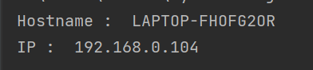

**2. Implement a Python Program to print host name and IP address of remote host where IP**

**address of remote host is available.**

**Source Code:**

import socket  
def check_ip():  
 try:  
 hname = socket.gethostname()  
 hip = socket.gethostbyname( hname )  
 print( "Host name : ", hname )  
 print( 'IP Address : ', hip )  
 except:  
 print( 'unable to get IP address' )  
 check_ip()

**Output:**



**3. Implement a Python Program to print host name and IP address of remote host where**

**hostname of remote host is available.**

**Source Code:**

import socket  
def check_hostname():  
 try:  
 hname=socket.gethostname()  
 hip=socket.gethostbyname(hname)  
 print("Host name : ",hname)  
 print('IP Address : ',hip)  
 except:  
 print('unable to get IP address')  
 check_hostname()

**Output:**



**4. Implement a TCP port scanner program in python for local host.**

**Source Code:**

from socket import *  
import time  
startTime = time.time()  
if __name__ == '__main__':  
 target = input('Enter the host to be scanned: ')  
 t_IP = gethostbyname(target)  
 print ('Starting scan on host: ', t_IP)  
 for i in range(50, 500):  
 s = socket(AF_INET, SOCK_STREAM)  
 conn = s.connect_ex((t_IP, i))  
if(conn == 0) :  
 print( 'Port %d: OPEN' % (i,) )  
 s.close()  
 print( 'Time taken:', time.time() - startTime )

**Output:**

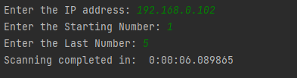

**5. Implement a UDP port scanner program in python for local host. (Note: Do not try this program**

**for a remote host, especially outside your domain. It could Cause Legal problems)**

**Source Code:**

import pyfiglet

import sys

import socket

from datetime import datetime

ascii_banner = pyfiglet.figlet_format("PORT SCANNER")

print(ascii_banner)

# Defining a target

if len(sys.argv) == 2:

# translate hostname to IPv4

target = socket.gethostbyname(sys.argv[1])

else:

print("Invalid ammount of Argument")

# Add Banner

print("-" * 50)

print("Scanning Target: " + target)

print("Scanning started at:" + str(datetime.now()))

print("-" * 50)

try:

# will scan ports between 1 to 65,535

for port in range(1, 65535):

s = socket.socket(socket.AF_INET, socket.SOCK_STREAM)

socket.setdefaulttimeout(1)

# returns an error indicator

result = s.connect_ex((target, port))

if result == 0:

print("Port {} is open".format(port))

s.close()

except KeyboardInterrupt:

print("\n Exitting Program !!!!")

sys.exit()

except socket.gaierror:

print("\n Hostname Could Not Be Resolved !!!!")

sys.exit()

except socket.error:

print("\ Server not responding !!!!")

sys.exit()

**Output:**

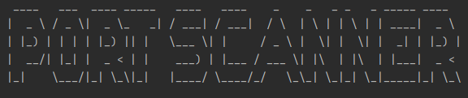

**6. Implement a TCP based client server program in python using TCP sockets where Server**

**displays the following: a) Host Name, IP address and Port Number on which it is hosted b) IP**

**address and port number of a client requesting connection. Server sends the message “Thanks for**

**Connecting!” back to client. Client displays this message on screen.**

**Source Code:**

Server Side :

import socket

server_socket=socket.socket(socket.AF_INET,socket.SOCK_STREAM)

port=12345

server_socket.bind(("127.0.0.1",port))

server_socket.listen(5)

while True:

print("Server waiting for connection")

client_socket,addr=server_socket.accept()

data=client_socket.recv(1024)

if not data or data.decode("utf-8")=="END":

break

print("received from client client: ",data.decode("utf-8"))

try:

hname=socket.gethostname()

hip=socket.gethostbyname(hname)

print("host-name: ",hname)

print("IP address: ",hip)

print("port number: ",port)

print("client connected from",addr)

client_socket.send(bytes("Thanks for connecting",'utf-8'))

except:

print("Exited by the user")

client_socket.close()

server_socket.close()

Client Side :

import socket

client_socket=socket.socket(socket.AF_INET,socket.SOCK_STREAM)

client_socket.connect(("127.0.0.1",12345))

payload="hey server"

try:

client_socket.send(payload.encode('utf-8'))

msg=client_socket.recv(1024)

print(msg)

except KeyboardInterrupt:

print("exit by user")

client_socket.close()

**Output:**





**7. Implement a UDP based client server program in python using UDP sockets where**

**Server displays the following:**

**a) Host Name, IP address and Port Number on which it is hosted**

**b) IP address and port number of a client sending some dummy message. Server**

**displays the dummy message on screen. Server sends the message “Thanks for**

**Message!” back to client. Client displays this message on screen.**

**Source Code:**

import socket

localIP = "127.0.0.1"

localPort = 20001

bufferSize = 1024

msgFromServer = "Thanks for message"

bytesToSend = str.encode(msgFromServer)

# Create a datagram socket

UDPServerSocket = socket.socket(family=socket.AF_INET, type=socket.SOCK_DGRAM)

# Bind to address and ip

UDPServerSocket.bind((localIP, localPort))

print("UDP server up and listening")

# Listen for incoming datagrams

while(True):

bytesAddressPair = UDPServerSocket.recvfrom(bufferSize)

message = bytesAddressPair[0]

address = bytesAddressPair[1]

clientMsg = "Message from Client:{}".format(message)

clientIP = "Client IP Address:{}".format(address)

hname=socket.gethostname()

print("server host: ",hname)

print("server IP: ",localIP)

print("port: ",localPort)

print(clientMsg)

print(clientIP)

# Sending a reply to client

UDPServerSocket.sendto(bytesToSend, address)

Client :

import socket

msgFromClient = "Hello UDP Server"

bytesToSend = str.encode(msgFromClient)

serverAddressPort = ("127.0.0.1", 20001)

bufferSize = 1024

# Create a UDP socket at client side

UDPClientSocket = socket.socket(family=socket.AF_INET, type=socket.SOCK_DGRAM)

# Send to server using created UDP socketUDPClientSocket.sendto(bytesToSend, serverAddressPort)

msgFromServer = UDPClientSocket.recvfrom(bufferSize)

msg = "Message from Server {}".format(msgFromServer[0])

print(msg)

**Output:**





**8. Implement a TCP based echo client server program in python**

**CODE:**

**Python-TCP-Server.py**

import socketserver

class Handler_TCPServer(socketserver.BaseRequestHandler):

def handle(self):

# self.request - TCP socket connected to the client

self.data = self.request.recv(1024).strip()

print("{} sent:".format(self.client_address[0]))

print(self.data)

# just send back ACK for data arrival confirmation

self.request.sendall("ACK from TCP Server".encode())

if __name__ == "__main__":

HOST, PORT = "localhost", 9999

# Init the TCP server object, bind it to the localhost on 9999 port

tcp_server = socketserver.TCPServer((HOST, PORT), Handler_TCPServer)

# Activate the TCP server.

# To abort the TCP server, press Ctrl-C.

tcp_server.serve_forever()

**Python-TCP-Client.py**

import socket

host_ip, server_port = "127.0.0.1", 9999

data = " Hello how are you?\n"

# Initialize a TCP client socket using SOCK_STREAM

tcp_client = socket.socket(socket.AF_INET, socket.SOCK_STREAM)

try:

# Establish connection to TCP server and exchange data

tcp_client.connect((host_ip, server_port))

tcp_client.sendall(data.encode())

# Read data from the TCP server and close the connection

received = tcp_client.recv(1024)

finally:

tcp_client.close()

print ("Bytes Sent: {}".format(data))

print ("Bytes Received: {}".format(received.decode()))

**OUTPUT:**

**Python-TCP-Server.py**

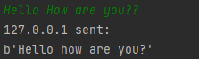

**Python-TCP-Client.py**

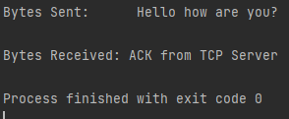

**9. Implement a UDP based echo client server program in python.**

**CODE:**

**Python-UDP-Server.py**

import socket  
  
localIP = "127.0.0.1"  
  
localPort = 20001  
  
bufferSize = 1024  
  
msgFromServer = "Hello UDP Client"  
  
bytesToSend = str.encode(msgFromServer)  
  
# Create a datagram socket  
  
UDPServerSocket = socket.socket(family=socket.AF_INET, type=socket.SOCK_DGRAM)  
  
# Bind to address and ip  
  
UDPServerSocket.bind((localIP, localPort))  
  
print("UDP server up and listening")  
  
# Listen for incoming datagrams  
  
while (True):  
 bytesAddressPair = UDPServerSocket.recvfrom(bufferSize)  
  
 message = bytesAddressPair[0]  
  
 address = bytesAddressPair[1]  
  
 clientMsg = "Message from Client:{}".format(message)  
 clientIP = "Client IP Address:{}".format(address)  
  
 print(clientMsg)  
 print(clientIP)  
  
 # Sending a reply to client  
  
 UDPServerSocket.sendto(bytesToSend, address)

**Python-UDP-Client.py**

import socket  
  
msgFromClient = "Hello UDP Server"  
  
bytesToSend = str.encode(msgFromClient)  
  
serverAddressPort = ("127.0.0.1", 20001)  
  
bufferSize = 1024  
  
# Create a UDP socket at client side  
  
UDPClientSocket = socket.socket(family=socket.AF_INET, type=socket.SOCK_DGRAM)  
  
# Send to server using created UDP socket  
  
UDPClientSocket.sendto(bytesToSend, serverAddressPort)  
  
msgFromServer = UDPClientSocket.recvfrom(bufferSize)  
  
msg = "Message from Server {}".format(msgFromServer[0])  
  
print(msg)

**OUTPUT:**

**Python-UDP-Server.py**

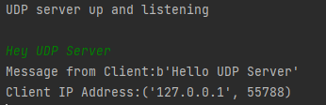

**Python-UDP-Client.py**

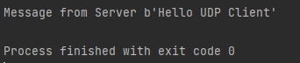

**10. Implement a TCP based daytime client server program in python**

**CODE:**

**DayTime-Server.py**

# server.py

import socket

import time

# create a socket object

serversocket = socket.socket(

socket.AF_INET, socket.SOCK_STREAM)

# get local machine name

host = socket.gethostname()

port = 9999

# bind to the port

serversocket.bind((host, port))

# queue up to 5 requests

serversocket.listen(5)

while True:

# establish a connection

clientsocket,addr = serversocket.accept()

print("Got a connection from %s" % str(addr))

currentTime = time.ctime(time.time()) + "\r\n"

clientsocket.send(currentTime.encode('ascii'))

clientsocket.close()

**DayTime-Client.py**

# client.py

import socket

# create a socket object

s = socket.socket(socket.AF_INET, socket.SOCK_STREAM)

# get local machine name

host = socket.gethostname()

port = 9999

# connection to hostname on the port.

s.connect((host, port))

# Receive no more than 1024 bytes

tm = s.recv(1024)

s.close()

print("The time got from the server is %s" % tm.decode('ascii'))

**OUTPUT:**

**DayTime-Server.py**



**DayTime-Client.py**



**11. Implement a UDP based daytime client server program in python.**

**Source Code:**

Server Side :

from datetime import datetime

import socket

localIP = "127.0.0.1"

localPort = 20001

bufferSize = 1024

# Create a datagram socket

UDPServerSocket = socket.socket(family=socket.AF_INET, type=socket.SOCK_DGRAM)

# Bind to address and ip

UDPServerSocket.bind((localIP, localPort))

bytesAddressPair = UDPServerSocket.recvfrom(bufferSize)

message = bytesAddressPair[0]

address = bytesAddressPair[1]

time=datetime.now()

time=str(time)

time=str.encode(time)

UDPServerSocket.sendto(time, address)

**Client Side:**

import socket

msgFromClient = "hello from client"

bytesToSend = str.encode(msgFromClient)

serverAddressPort = ("127.0.0.1", 20001)

bufferSize = 1024

# Create a UDP socket at client side

UDPClientSocket = socket.socket(family=socket.AF_INET, type=socket.SOCK_DGRAM)

# Send to server using created UDP socket

UDPClientSocket.sendto(bytesToSend, serverAddressPort)

timeFromServer = UDPClientSocket.recvfrom(bufferSize)

time=format(timeFromServer[0])

print(time)

**Output:**



**12. Implement a TCP based client server text chat program in python.**

**CODE:**

**Chat-Server.py**

# server.py

import time, socket, sys

print("\nWelcome to Chat Room\n")

print("Initialising....\n")

time.sleep(1)

s = socket.socket()

host = socket.gethostname()

ip = socket.gethostbyname(host)

port = 1234

s.bind((host, port))

print(host, "(", ip, ")\n")

name = input(str("Enter your name: "))

s.listen(1)

print("\nWaiting for incoming connections...\n")

conn, addr = s.accept()

print("Received connection from ", addr[0], "(", addr[1], ")\n")

s_name = conn.recv(1024)

s_name = s_name.decode()

print(s_name, "has connected to the chat room\nEnter [e] to exit chat room\n")

conn.send(name.encode())

while True:

message = input(str("Me : "))

if message == "[e]":

message = "Left chat room!"

conn.send(message.encode())

print("\n")

break

conn.send(message.encode())

message = conn.recv(1024)

message = message.decode()

print(s_name, ":", message)

**Chat-Client.py**

# client.py

import time, socket, sys

print("\nWelcome to Chat Room\n")

print("Initialising....\n")

time.sleep(1)

s = socket.socket()

shost = socket.gethostname()

ip = socket.gethostbyname(shost)

print(shost, "(", ip, ")\n")

host = input(str("Enter server address: "))

name = input(str("\nEnter your name: "))

port = 1234

print("\nTrying to connect to ", host, "(", port, ")\n")

time.sleep(1)

s.connect((host, port))

print("Connected...\n")

s.send(name.encode())

s_name = s.recv(1024)

s_name = s_name.decode()

print(s_name, "has joined the chat room\nEnter [e] to exit chat room\n")

while True:

message = s.recv(1024)

message = message.decode()

print(s_name, ":", message)

message = input(str("Me : "))

if message == "[e]":

message = "Left chat room!"

s.send(message.encode())

print("\n")

break

s.send(message.encode())

**OUTPUT:**

**Chat-Server.py**

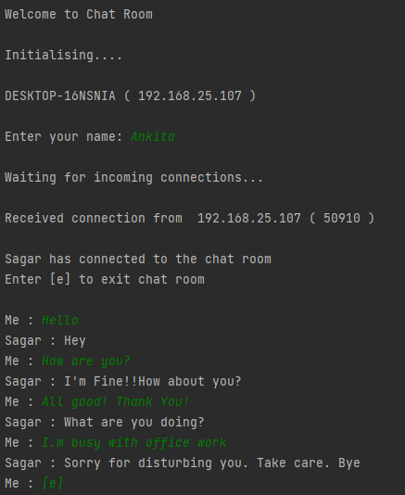

**Chat-Client.py**

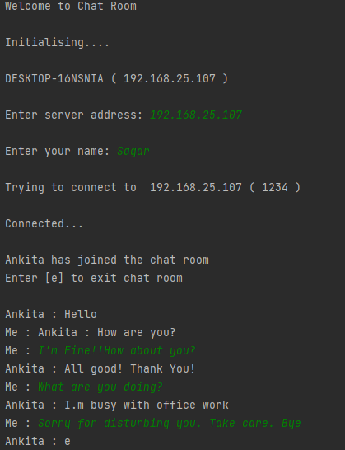

**13. Implement a UDP based client server text chat program in python.**

**Source Code:**

Server Side :

import socket

localIP = "127.0.0.1"

localPort = 20001

bufferSize = 1024

msgFromServer = "Start chat"

bytesToSend = str.encode(msgFromServer)

# Create a datagram socket

import socket

localIP = "127.0.0.1"

localPort = 20001

bufferSize = 1024

msgFromServer = "Start chat"

bytesToSend = str.encode(msgFromServer)

Create a datagram socket

UDPServerSocket = socket.socket(family=socket.AF_INET, type=socket.SOCK_DGRAM)

# Bind to address and ip

UDPServerSocket.bind((localIP, localPort))

print("UDP server up and listening")

# Listen for incoming datagrams

while True:

bytesAddressPair = UDPServerSocket.recvfrom(bufferSize)

address = bytesAddressPair[1]

clientMsg = format(bytesAddressPair[0])

print(clientMsg)

message=input(' -> ')

bytesToSend = str.encode(message)

UDPServerSocket.sendto(bytesToSend, address)

Client Side :

import socket

serverAddressPort = ("127.0.0.1", 20001)

bufferSize = 1024

# Create a UDP socket at client side

UDPClientSocket = socket.socket(family=socket.AF_INET, type=socket.SOCK_DGRAM)

message = input(' -> ')

bytesToSend = str.encode(message)

while message.lower().strip() != 'bye':

UDPClientSocket.sendto(bytesToSend, serverAddressPort)

msgFromServer = UDPClientSocket.recvfrom(bufferSize)

msg = format(msgFromServer[0])

print(msg) # show in terminal

message = input(" -> ") # again take input

bytesToSend = str.encode(message)

**Output:**





**14. Implement a TCP based echo client server program in python with a multi-threaded server.**

**Source Code:**

Server Side :

# import socket programming library

import socket

# import thread module

from _thread import *

import threading

print_lock = threading.Lock()

# thread function

def threaded(c):

while True:

# data received from client

data = c.recv(1024)

if not data:

print('Bye')

# lock released on exit

print_lock.release()

break

# reverse the given string from client

data = data[::-1]

# send back reversed string to client

c.send(data)

# connection closed

c.close()

def Main():

host = ""

# reverse a port on your computer

# in our case it is 12345 but it

# can be anything

port = 12345

s = socket.socket(socket.AF_INET, socket.SOCK_STREAM)

s.bind((host, port))

print("socket binded to port", port)

# put the socket into listening mode

s.listen(5)

print("socket is listening")

# a forever loop until client wants to exit

while True:

# establish connection with client

c, addr = s.accept()

# lock acquired by client

print_lock.acquire()

print('Connected to :', addr[0], ':', addr[1])

# Start a new thread and return its identifier

start_new_thread(threaded, (c,))

s.close()

if __name__ == '__main__':

Main()

Client Side :

# Import socket module

import socket

def Main():

# local host IP '127.0.0.1'

host = '127.0.0.1'

# Define the port on which you want to connect

port = 12345

s = socket.socket(socket.AF_INET,socket.SOCK_STREAM)

# connect to server on local computer

s.connect((host,port))

# message you send to server

message = "shaurya says geeksforgeeks"

while True:

# message sent to server

s.send(message.encode('ascii'))

# messaga received from server

data = s.recv(1024)

# print the received message

# here it would be a reverse of sent message

print('Received from the server :',str(data.decode('ascii')))

# ask the client whether he wants to continue

ans = input('\nDo you want to continue(y/n) :')

if ans == 'y':

continue

else:

break

# close the connection

s.close()

if __name__ == '__main__':

Main()

**Output:**





**15. Implement a TCP based daytime client server program in python with a multithreaded**

**Source Code:**

Server Side :

from os import times

import socket

from _thread import *

import threading

from datetime import datetime

print_lock = threading.Lock()

bufferSize = 1024

def threaded(s):

while True:

data = s.recvfrom(bufferSize)

addr=data[1]

msg=format(addr[0])

if not msg:

print('Bye')

print_lock.release()

break

rightnow=datetime.now()

rightnow=str(rightnow)

bytesToSend = str.encode(rightnow)

s.sendto(bytesToSend,addr)

s.close()

def Main():

host = ""

port = 12345

s = socket.socket(socket.AF_INET, socket.SOCK_DGRAM)

s.bind((host, port))

print("socket binded to port", port)

print("socket is listening")

while True:

print_lock.acquire()

start_new_thread(threaded, (s,))

s.close()

if __name__ == '__main__':

Main()

Client Side :

import socket

bufferSize=1024

def Main():

host = '127.0.0.1'

port = 12345

s = socket.socket(socket.AF_INET,socket.SOCK_DGRAM)

s.connect((host,port))

message = "Hello"

bytesToSend = str.encode(message)

serverAddressPort=(host,port)

s.sendto(bytesToSend, serverAddressPort)

data = s.recvfrom(bufferSize)

msg = format(data[0])

print('Received from the server :',msg)

s.close()

if __name__ == '__main__':

Main()

**Output:**





**16. Implement a web client using urllib to:**

**a) Display the html source of a given URL on screen**

**b) Display the URL visited**

**c) Display the header information transmitted in the http response sent by the**

**contacted web-site/web-server.**

**d) Display the http server status code**

**Source Code:**

import urllib.request

from http import HTTPStatus

url="http://python.org"

with urllib.request.urlopen(url) as response:

print("HTML code: \n",response.read())

print("URL: ",url)

print("Headers: ",response.headers)

print("Status code:", HTTPStatus.OK.value)

**Output:**





**17. Implement an ftp client using ftplib which connects to an ftp server, takes**

**login/password from user, displays directory list and permits upload and download**

**of files.**

**Source Code:**

import ftplib

hostname='ftp.dlptest.com'

username='dlpuser'

password='rNrKYTX9g7z3RgJRmxWuGHbeu'

ftp_server=ftplib.FTP(hostname,username,password)

ftp_server.encoding='utf-8'

filename="demoDev.txt"

with open(filename,'rb') as file:

ftp_server.storbinary(f"STOR {filename}",file)

ftp_server.dir()

with open(filename,'wb') as file:

ftp_server.retrbinary(f"RETR {filename}", file.write)

**Output:**



**18. Write a Python program that makes a connection to a web server and retrieve/display a document using the HTTP protocol.**

**CODE:**

import socket

mysock = socket.socket(socket.AF_INET, socket.SOCK_STREAM)

mysock.connect(('data.pr4e.org', 80))

cmd = 'GET http://data.pr4e.org/romeo.txt HTTP/1.0\r\n\r\n'.encode()

mysock.send(cmd)

while True:

data = mysock.recv(512)

if len(data) < 1:

break

print(data.decode(),end='')

mysock.close()

**OUTPUT:**

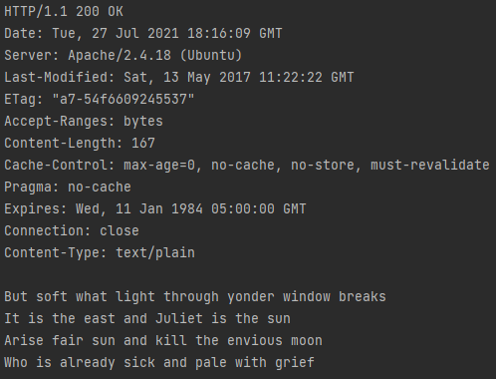

**19. Write a Python program that makes a connection to a web server and retrieve an**

**image using the HTTP protocol.**

**Source Code:**

import requests

recv= requests.get('https://imgs.xkcd.com/comics/making_progress.png')

with open(r'C:\Users\devpa\OneDrive\Documents\sem 2\python\image.png','wb') as f:

f.write(recv.content)

**Output:**



**20. Write a python program to implement a simple server-client program .**

**CODE:**

**CN_20-Server.py**

import socket

def server_program():

# get the hostname

host = socket.gethostname()

port = 5000 # initiate port no above 1024

server_socket = socket.socket() # get instance

# look closely. The bind() function takes tuple as argument

server_socket.bind((host, port)) # bind host address and port together

# configure how many client the server can listen simultaneously

server_socket.listen(2)

conn, address = server_socket.accept() # accept new connection

print("Connection from: " + str(address))

while True:

# receive data stream. it won't accept data packet greater than 1024 bytes

data = conn.recv(1024).decode()

if not data:

# if data is not received break

break

print("from connected user: " + str(data))

data = input(' -> ')

conn.send(data.encode()) # send data to the client

conn.close() # close the connection

if __name__ == '__main__':

server_program()

**CN_20-Client.py**

import socket

def client_program():

host = socket.gethostname() # as both code is running on same pc

port = 5000 # socket server port number

client_socket = socket.socket() # instantiate

client_socket.connect((host, port)) # connect to the server

message = input(" -> ") # take input

while message.lower().strip() != 'bye':

client_socket.send(message.encode()) # send message

data = client_socket.recv(1024).decode() # receive response

print('Received from server: ' + data) # show in terminal

message = input(" -> ") # again take input

client_socket.close() # close the connection

if __name__ == '__main__':

client_program()

**OUTPUT:**

**CN_20-Server.py**

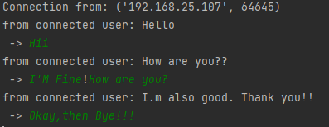

**CN_20-Client.py**

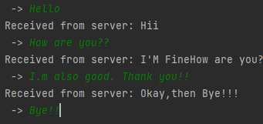

**21. Write a python program to implement socket programming using multi-threading**

**Source Code:**

# import socket programming library

import socket

# import thread module

from _thread import *

import threading

print_lock = threading.Lock()

# thread function

def threaded(c):

while True:

# data received from client

data = c.recv(1024)

if not data:

print('Bye')

# lock released on exit

print_lock.release()

break

# reverse the given string from client

data = data[::-1]

# send back reversed string to client

c.send(data)

# connection closed

c.close()def Main():

host = ""

# reverse a port on your computer

# in our case it is 12345 but it

# can be anything

port = 12345

s = socket.socket(socket.AF_INET, socket.SOCK_STREAM)

s.bind((host, port))

print("socket binded to port", port)

# put the socket into listening mode

s.listen(5)

print("socket is listening")

# a forever loop until client wants to exit

while True:

# data received from client

data = c.recv(1024)

if not data:

print('Bye')

# lock released on exit

print_lock.release()

break

# reverse the given string from client

data = data[::-1]

# send back reversed string to client

c.send(data)

# connection closed

c.close()

def Main():

host = ""

# reverse a port on your computer

# in our case it is 12345 but it

# can be anything

port = 12345

s = socket.socket(socket.AF_INET, socket.SOCK_STREAM)

s.bind((host, port))

print("socket binded to port", port)

# put the socket into listening mode

s.listen(5)

print("socket is listening")

# a forever loop until client wants to exit

while True:

# establish connection with client

c, addr = s.accept()

# lock acquired by client

print_lock.acquire()

print('Connected to :', addr[0], ':', addr[1]) # Start a new thread and return its identifier

start_new_thread(threaded, (c,))

s.close()

if __name__ == '__main__':

Main()

Client Side :

# import socket programming library

import socket

# import thread module

from _thread import *

import threading

print_lock = threading.Lock()

# thread function

def threaded(c):

while True:

# Import socket module

import socket

def Main():

# local host IP '127.0.0.1'

host = '127.0.0.1'

# Define the port on which you want to connect

port = 12345s = socket.socket(socket.AF_INET,socket.SOCK_STREAM)

# connect to server on local computer

s.connect((host,port))

# message you send to server

message = "shaurya says geeksforgeeks"

while True:

# message sent to server

s.send(message.encode('ascii'))

# messaga received from server

data = s.recv(1024)

# print the received message

# here it would be a reverse of sent message

print('Received from the server :',str(data.decode('ascii')))

# ask the client whether he wants to continue

ans = input('\nDo you want to continue(y/n) :')

if ans == 'y':

continue

else:

break

# close the connection

s.close()

if __name__ == '__main__':

Main()

**Output:**



